<page_start no = 1>
<sol_start id=1>
1. (3) 3 : 2
<sol_end>

<sol_start id=2>
2. (1) ₹ 360
<sol_end>

<sol_start id=3>
3. (1) Convergent lens
<sol_end>
<page_end>

<page_start no = 2>
<sol_start id=4>
4. (2) Common defect of vision
(1) Myopia
(2) Hypermetropia
Myopia can be corrected by using concave lens
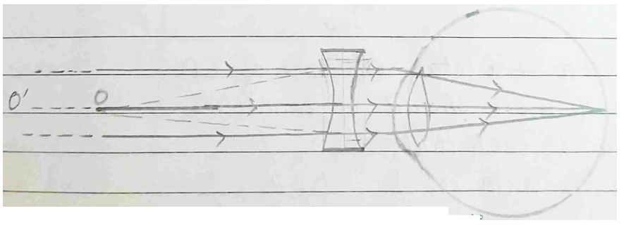
Correction for Myopia

Hypermetropia can be corrected by using convex lens
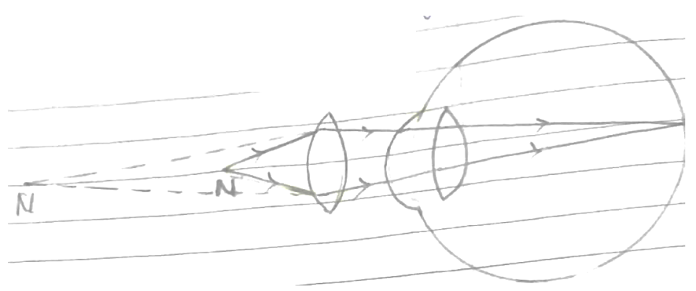
Correction for Hypermetropia

<sol_end>

<sol_start id=5>
<sub_id = 1>
5.(i) Reading of Ammeter will be the total current flowing in the circuit.
So, now, equivalent resistance = 8 + 5 + 12 = 25Ω
Total voltage = 2V + 2V + 2V
= 6 V
Current =
∴ Reading of Ammeter = 0.24 A
Reading of voltmeter will be the voltage of across 12Ω resistor
Voltage across 12Ω resistor =
=
∴ Reading of voltmeter = 2.88 V
<sub_id end>
<sub_id = 2>
(ii) To give a total resistance of 1Ω, all the resistors should be connected in parallel, such that,
Equivalent Resistance,
To give a total resistance of 40, 30 and 6Ω resistors need to be connected in parallel and 2Ω resistor should be connected in series with the combination of 3Ω and 6Ω resistors, such that,
Now, 2Ω + 2Ω = 4Ω, which is the required total resistance.
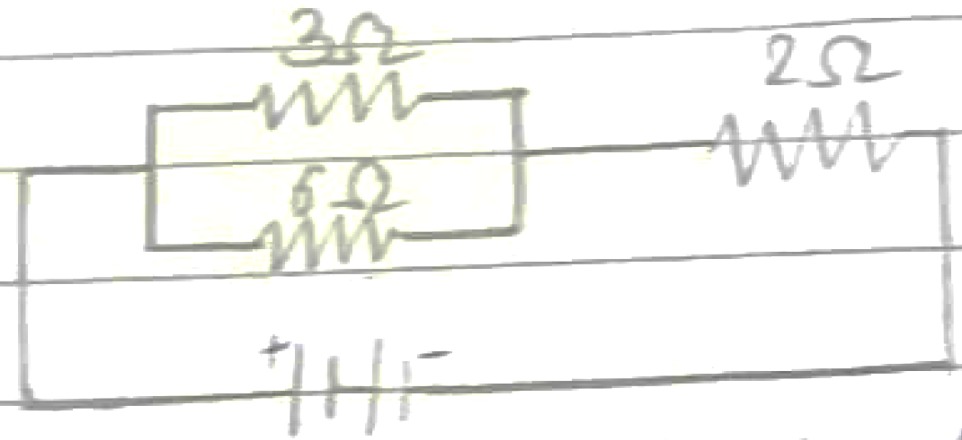
Diagramatic representation of 4Ω total resistance.
<sub_id end>
<sol_end>
<page_end>

<page_start no = 3>
<sol_start id=6>
<sub_id = 1>
6.(i) (1) For point of myopic eye, v = –80 cm
u = –∞
f, focal length = ?
Using lens formula, we get,
Now, f = –0.8 m
Power,
Nature of lens = Divergent, which is a concave lens.
<sub_id end>
<sub_id = 2>
(ii) Power of accommodation is the ability of eye lens to adjust its focal length, this ability of eye lens is controlled by ciliary muscles when the ciliary muscles contract, then the focal length of eye lens is less and when ciliary muscles relax, then its focal length of crystalline eye lens is more.
<sub_id end>
<sub_id = 3>
(iii) Role of iris :
- Controls the amount of light to be entered in the eye.
(2) Determines the colour of eye.
(3) Controls the size of pupil.
<sub_id end>
<sol_end>
<page_end>

